**ASSIGNMENT I**

**BIT 302**

**Software Engineering**



**Project Proposal**

**Covid Testing Information System (CTIS)**

**Prepared by:**

Team Leader: Pande Putu Rama Pratama Putra (E1700877)

I Nengah Wahyudi Setiawan (E1200255)

Contact Details:

[ramapratama657@gmail.com](mailto:ramapratama657@gmail.com)

[@gmail.com](mailto:sidi.meisanjaya2013@gmail.com)

2021/2022

**Table of Content**

1. Overview
2. Projects Aims
3. Project Objective
4. Project Scope
5. Project Schedule

* Work Breakdown Structure
* Milestones
* Gantt Chart

1. Technical Description

* Development Platform
* Demonstration Platform

1. Risk Management Plan

**Overview**

Corona virus or “Severe Acute Respiratory Syndrome Coronavirus 2” (SARS-CoV-2) is a virus that attacks the respiratory system. This disease due to viral infection is called COVID-19. The Corona virus can cause minor disorders of the respiratory system, severe lung infections, and death. Corona virus infection is called COVID-19 (Corona Virus Disease 2019) and was first discovered in the city of Wuhan, China at the end of December 2019. This virus is spreading very quickly and has spread to almost all countries, including Indonesia, in just a few months.

During this pandemic, there are hundreds to millions of thousands of people who have tested positive for Covid. For doctors and health experts, it is a very large number and it is undeniable that each medical center controls patients who are divided from those who are positive for Covid, are currently in quarantine, are suspended, and who have recovered from Covid. Our motivation is to want to help each medical center to manage every covid history for each patient, controlling the growth of this Covid case. So we want to make a website application which is aimed at each medical center to make it easier to control and store the test results of each patient who has visited the medical center.

In addition, we also want to make this website application to help patients track their status history and get important info about Covid. For now, there are already several covid testing information system applications in each country and each country has different functions in presenting this application, and for Indonesia, there is a website application which can register everyone to get this Covid vaccine. However, until now there is no application that makes it easier for every medical center and patients to track the covid history. The cost required in making this application is Rp. The duration of making this application is 3 months to complete this application

**Project Aims**

* To help medical center for manage every patients were have positive Covid, in Quarantine, suspended, or recovered from Covid.
* To create a system that updates the patient’s status database that generates from administrator.
* To make clear all information about all data and patients can see their status about Covid.

**Project Objects**

* Gather all Documents, data, and all the information that useful for this project.
* Find and use the tools and software programming language that suitable and useful for develop this project.
* Create a website application with easy – to – use interface.
* Create a Database and input all the data and information that has been collected.
* Intergrating the Website and Database to build this website application.

**Project Scope**

|  |
| --- |
| **Project Title:** Covid Testing Information System (CTIS)  **Date:** February 1 , 2021  **Prepared by:** Rama Pratama, Project Team Leader, ramapratama657@gmail.com |
| **Project Summary and Justification:**  In this Website Application, we want to help medical center for make it easier to handle patients Covid. With attractive interface and easy – to – use, and features available that useful for administrator and patients(user) for manage and generates their status report. |
| **Product Characteristics and Requirements:**   1. Attractive and easy – to – use features and interfaces for administrators and user that can check status report Covid. And also, administrator can update report status for patients. 2. All features in this website application must tested before to avoid things like errors and bugs 3. Make sure for the program can run properly and efficiency. |
| **Summary of Project Deliverables**  **Project management-related deliverables:** Project Aims, Project Objectives, Project Scope Statement, WBS (Work Breakdown Structure), Schedule, Cost Baseline, Requirements Specification Document, Design and Testing Documentation, Website-based Covid Testing Information System that is useful and can work, Final Project Presentation required to manage the project.  **Product-related deliverables:**   1. Website Application Covid Testing Information System managed and accessed by administrators from medical center. Information system for user that can be accessed anytime and anywhere. 2. The content on this website contains features to recap and manage and know the data of each User’s history status and data. 3. Web appearance will be made simple and easy – to – use by ordinary people, so that users and administrator are comfortable when using it. |
| **Project Success Criteria:**  This project will be completed in 3 months. The success of this project is measured by the requirements and all characteristics. This project can greatly help many people, including medical center and the user(patients). Also, The information system will develop rapidly because it is very much used in this era of the Corona pandemic. |

**Project Schedule**

|  |  |  |  |  |  |  |
| --- | --- | --- | --- | --- | --- | --- |
| **Schedule** | **Start Date** | | **End Date** | | **Estimate Days** | **Responsible** |
| **Initiating Task** | | | | | | |
| Determining Topic | Mon, 01/02/2021 | | Mon, 01/02/2021 | | 1 | All |
| Overview Project | Tue, 02/02/2021 | | Thu, 04/02/2021 | | 3 | Wahyudi |
| Analysis Project Aims and Project Objective | Tue, 02/02/2021 | | Thu, 04/02/2021 | | 3 | Rama |
| Project Scope | Mon, 08/02/2021 | | Wed, 10/02/2021 | | 3 | All |
| Complete Initiating Task (Milestones) | Thu, 11/02/2021 | | Thu, 11/02/2021 | | 0 | All |
| **Planning Task** | | | | | | |
| Work Breakdown Structure | Fri, 12/02/2021 | | Sat, 13/02/2021 | | 2 | Wahyudi |
| Develop Deliverables | Fri, 12/02/2021 | | Sat, 13/02/2021 | | 2 | Rama |
| Baseline Gantt Chart | Mon, 15/02/2021 | | Tue, 16/02/2021 | | 2 | Rama |
| Resource Planning | Wed, 17/02/2021 | | Mon, 22/02/2021 | | 6 | All |
| Risk Management Plan | Tue, 23/02/2021 | | Thu, 25/02/2021 | | 3 | Wahyudi |
| Requirements Definition | Fri, 26/02/2021 | | Mon, 01/03/2021 | | 4 | All |
| Use Case Diagram | Tue, 02/03/2021 | | Wed, 03/03/2021 | | 2 | Wahyudi |
| Class Diagram and Work Division | Tue, 02/03/2021 | | Wed, 03/03/2021 | | 2 | Rama |
| System Sequence Diagrams and Contracts | Thu, 04/03/2021 | | Sat, 06/03/2021 | | 3 | All |
| Set Up GitHub | Mon, 08/03/2021 | | Tue, 09/03/2021 | | 2 | All |
| Assignment 1 Submission (Milestones) | Wed, 10/03/2021 | | Wed, 10/03/2021 | | 0 | All |
| **Executing Task** | | | | | | |
| Develop Site Map | Thu, 11/03/2021 | | Fri, 12/03/2021 | | 2 | Rama |
| Design Class Diagram | Thu, 11/03/2021 | | Fri, 12/03/2021 | | 2 | Wahyudi |
| Updating System Sequence Diagram | Mon, 15/03/2021 | | Tue, 16/03/2021 | | 2 | All |
| ERD and Database | Wed, 17/03/2021 | | Fri, 19/03/2021 | | 3 | All |
| Wire Frames | Mon, 22/03/2021 | | Tue, 23/03/2021 | | 2 | All |
| Develop Prototype 1 | Wed, 24/03/2021 | | Mon, 29/03/2021 | | 6 | All |
| Produce Prototype 1 (Milestones) | Tue, 30/03/2021 | | Tue, 30/03/2021 | | 1 | All |
| **Iteration 1** | | | | | | |
| Test Objectives | Wed, 31/03/2021 | | Wed, 31/03/2021 | | 1 | All |
| Develop Test Plan | Thu, 01/04/2021 | | Fri, 02/04/2021 | | 2 | Rama |
| Produce Test Result | Mon, 05/04/2021 | | Mon, 05/04/2021 | | 1 | Wahyudi |
| Analysis Report | Mon, 05/04/2021 | | Mon, 05/04/2021 | | 1 | Rama |
| Presentation Preparation | Tue, 06/04/2021 | | Wed, 07/04/2021 | | 2 | All |
| Presentation and Assignment 2 (Milestones) | Thu, 08/04/2021 | | Thu, 08/04/2021 | | 1 | All |
| Problem Solutions | Fri, 09/04/2021 | | Fri, 09/04/2021 | | 1 | All |
| Analysis/Design Updates | Mon, 12/04/2021 | | Mon, 12/04/2021 | | 1 | All |
| Develop Prototype 2 | Tue, 13/04/2021 | | Fri, 16/04/2021 | | 4 | All |
| Produce Prototype 2 (Milestones) | Sat, 17/04/2021 | | Sat, 17/04/2021 | | 0 | All |
| **Iteration 2** | | | | | | |
| Test Objectives | Sat, 17/04/2021 | | Mon, 19/04/2021 | | 2 | All |
| Update Test Plan | Tue, 20/04/2021 | | Tue, 20/04/2021 | | 1 | Wahyudi |
| Produce Test Resource | Wed, 21/04/2021 | | Wed, 21/04/2021 | | 1 | All |
| Test Analysis Report | Thu, 22/04/2021 | | Thu, 22/04/2021 | | 1 | Rama |
| Produce Conclusion | Fri, 23/04/2021 | | Fri, 23/04/2021 | | 1 | All |
| **Monitoring and Controlling Task** | | | | | | |
| Update Gantt Chart 1 | | Mon, 05/04/2021 | | Tue, 06/04/2021 | 2 | All |
| Update Gantt Chart 2 | | Thu, 22/04/2021 | | Thu, 22/04/2021 | 1 | All |
| **Closing Task** | | | | | | |
| Presentation Preparation | | Sat, 24/04/2021 | | Tue, 27/04/2021 | 4 | All |
| Presentation and Assignment 3 Submission (Milestones) | | Wed, 28/04/2021 | | Wed, 28/04/2021 | 0 | All |

**Work Breakdown Structure**

1. Initiating Task
   1. Determining Topic
   2. Overview
   3. Analysis Project Aims and Project Objectives
   4. Project Scope
   5. Complete Initiating Task (Milestones)
2. Planning Task
3. Work Breakdown Structure
4. Develop Deliverables
5. Baseline Gantt Chart
6. Resource Planning
7. Risk Management Plan
8. Requirements Definition
9. Use Case Diagram
10. Class Diagram and Work Division
11. System Sequence Diagram and Contracts
12. Set Up GitHub
13. Assignment 1 Submission (Milestones)
14. Executing Task
15. Develop Site Map
16. Designing Class Diagram
17. Updating System Sequence Diagram
18. ERD and Database
19. Wire Frames
20. Develop Prototype 1
21. Produce Prototype 1 (Milestones)
22. Iteration 1
    * 1. Test Objectives
      2. Develop Test Plan
      3. Produce Test Result
      4. Analysis Report
    1. Presentation Preparation
    2. Presentation and Assignment 2 (Milestones)
    3. Problems Solutions
    4. Analysis/Design Updates
    5. Develop Prototype 2
    6. Produce Prototype 2 (Milestones)
    7. Iteration 2
       1. Test Objectives
       2. Update Test Plan
       3. Produce Test Result
       4. Test Analysis Report
       5. Produce Conclusion
23. Monitoring and Controlling Task
24. Update Gantt Chart 1
25. Update Gantt Chart 2
26. Closing Task
27. Presentation Preparation
28. Presentation and Assignment 3 Submission (Milestones)

**Milestones/Deliverables**

|  |  |  |  |
| --- | --- | --- | --- |
| **No.** | **Milestones Name** | **Phase** | **Expected Completion Date** |
| 1 | Complete Initiating Task | Initiating Task | February 11, 2021 |
| 2 | Assignment 1 Submission | Planning Task | March 10, 2021 |
| 3 | Produce Prototype 1 | Executing task | March 30, 2021 |
| 4 | Presentation and Assignment 2 | Executing task | April 08, 2021 |
| 5 | Produce Prototype 2 | Executing task | April 17, 2021 |
| 6 | Presentation and Assignment 3 Submission | Closing Task | April 28, 2019 |

**Baselines Gantt Charts**

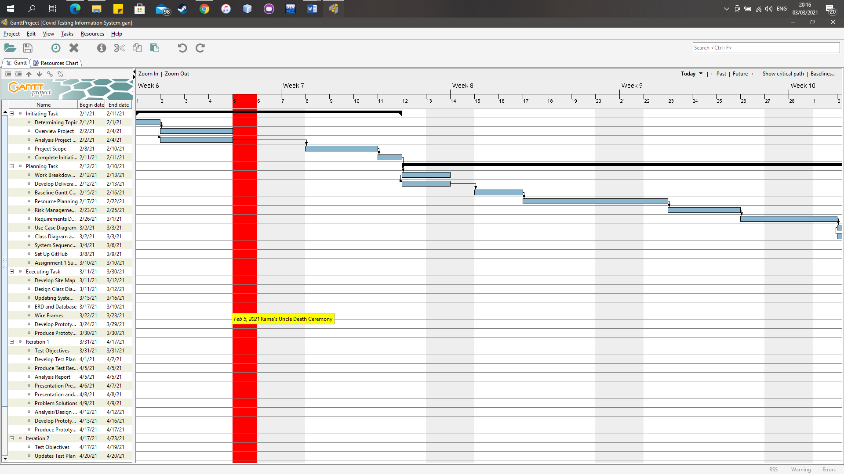

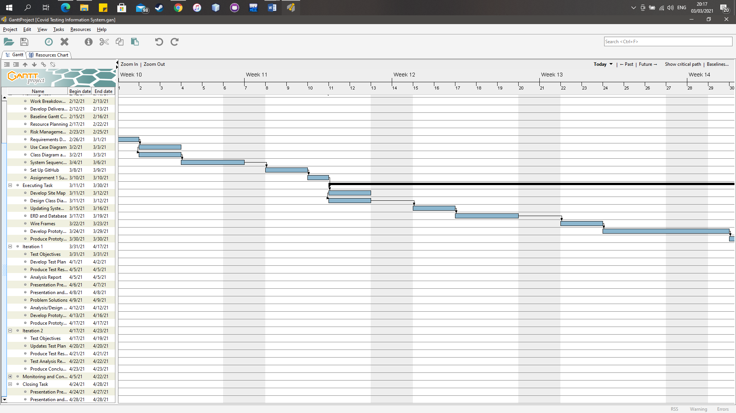

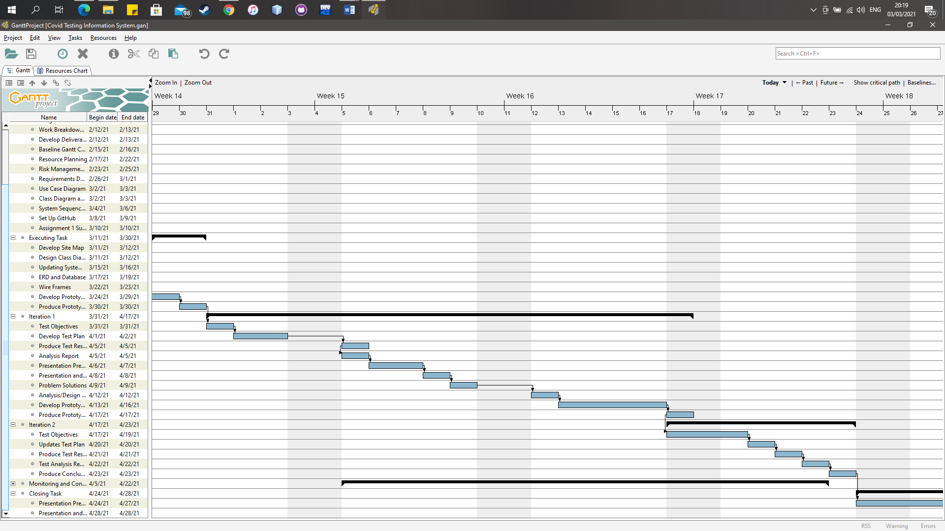

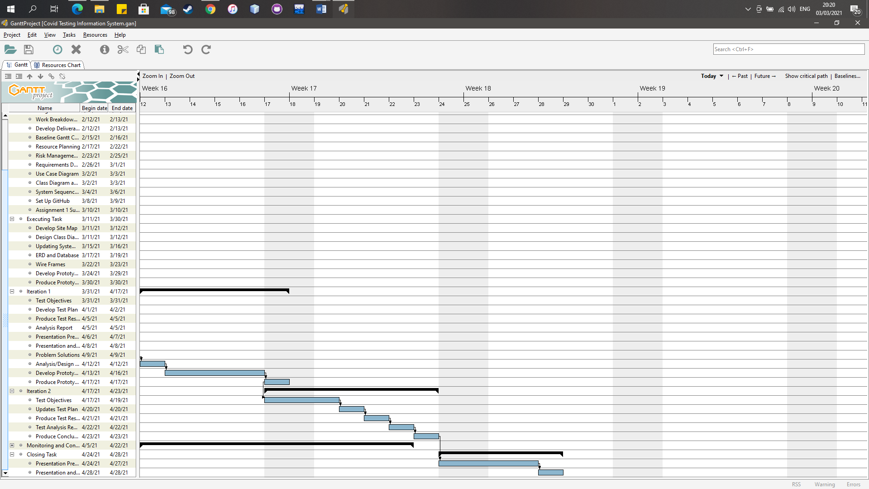

**Technical Description of the Proposed System**

**Development Platform**

**Software:**

Asasasa

**Hardware:**

Asasasas

**Demonstration Platform**

**Software:**

Asasasa

**Hardware:**

Asasasas

**Risk Management Plan**

**References**

O’Neil ,Patrick Howell, Tate Ryan-Mosley, and Bobbie Johnson. 2020. A Flood of coronavirus apps are tracking us. Now it’s time to keep track of them. MIT Technology Review. https://www.technologyreview.com/2020/05/07/1000961/launching-mittr-covid-tracing-tracker/

Kementrian Komunikasi dan Informatika. 2020. PeduliLindungi. https://pedulilindungi.id/